**UAS MOBILE COMPUTING**

**Nama : TEGUH PRAYITNO**

**Nim : 17164035**

**Pertama Spash screen**

**Coding xml**

<?xml version="1.0" encoding="utf-8"?>  
<RelativeLayout xmlns:android="http://schemas.android.com/apk/res/android"  
 xmlns:tools="http://schemas.android.com/tools"  
 android:id="@+id/activity_main"  
 android:layout_width="match_parent"  
 android:layout_height="match_parent"  
 android:background="#FFFFFF"  
 android:gravity="center"  
 tools:context="com.example.splashscreeen.MainActivity">  
  
 <ImageView  
 android:layout_width="500dp"  
 android:layout_height="200dp"  
 android:id="@+id/logo"  
 android:src="@drawable/download1"  
 android:layout_centerVertical="true"  
 android:layout_alignParentLeft="true"  
 android:layout_alignParentStart="true" />  
  
</RelativeLayout>

**Main activity.java**

package com.example.splashscreeen;  
  
import android.content.Intent;  
import android.os.Bundle;  
import android.os.Handler;  
import android.view.View;  
  
import androidx.appcompat.app.AppCompatActivity;  
  
public class MainActivity extends AppCompatActivity {  
 private int waktu_loading=4000;  
 //4000=4 detik  
  
 @Override  
 protected void onCreate(Bundle savedInstanceState) {  
 super.onCreate(savedInstanceState);  
  
 setContentView(R.layout.*activity_main*);  
 new Handler().postDelayed(new Runnable() {  
 @Override  
 public void run() {  
  
 //setelahloading maka akan langsung berpindah ke home activity  
 Intent login=new Intent(MainActivity.this, login.class);  
 startActivity(login);  
 finish();  
 }  
 },waktu_loading);  
 }  
  
}

**Tampilan dari spash screen ke login setelah 4 detik**

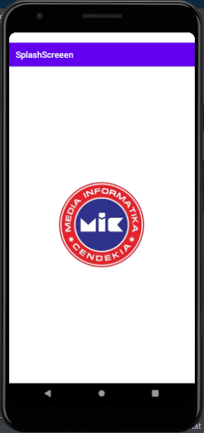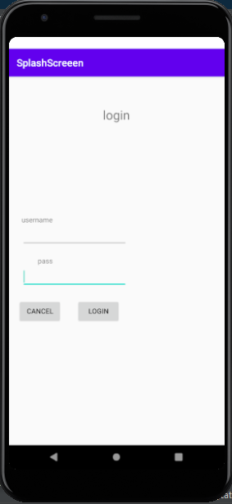

**Kedua Mauk halama login.**

**Login.xml**

<?xml version="1.0" encoding="utf-8"?>  
<RelativeLayout xmlns:android="http://schemas.android.com/apk/res/android"  
 xmlns:tools="http://schemas.android.com/tools#8221"  
 android:layout_width="match_parent"  
 android:layout_height="match_parent"  
 android:paddingBottom="@dimen/activity_vertical_margin"  
 android:paddingLeft="@dimen/activity_horizontal_margin"  
 android:paddingRight="@dimen/activity_horizontal_margin"  
 android:paddingTop="@dimen/activity_vertical_margin"  
 tools:context="com.example.splashscreeen.login"  
 android:orientation="vertical">  
  
 <EditText  
 android:id="@+id/edtPass"  
 android:layout_width="wrap_content"  
 android:layout_height="wrap_content"  
 android:layout_alignLeft="@+id/edtUser"  
 android:layout_below="@+id/textView3"  
 android:ems="10"  
 android:inputType="textPassword"/>  
  
 <EditText  
 android:id="@+id/edtUser"  
 android:layout_width="wrap_content"  
 android:layout_height="wrap_content"  
 android:layout_above="@+id/textView3"  
 android:layout_alignLeft="@+id/textView1"  
 android:layout_marginBottom="18dp"  
 android:ems="10"  
 android:inputType="textPersonName"/>  
  
 <Button  
 android:id="@+id/btnCancel"  
 android:layout_width="wrap_content"  
 android:layout_height="wrap_content"  
 android:layout_below="@+id/edtPass"  
 android:layout_marginRight="29dp"  
 android:layout_marginTop="22dp"  
 android:layout_toLeftOf="@+id/btnLogin"  
 android:text="@string/cancel"/>  
  
 <Button  
 android:id="@+id/btnLogin"  
 android:layout_width="wrap_content"  
 android:layout_height="wrap_content"  
 android:layout_alignBaseline="@+id/btnCancel"  
 android:layout_alignBottom="@+id/btnCancel"  
 android:layout_alignRight="@+id/edtUser"  
 android:layout_marginRight="14dp"  
 android:onClick="login"  
 android:text="@string/login"/>  
  
 <TextView  
 android:id="@+id/textView1"  
 android:layout_width="wrap_content"  
 android:layout_height="wrap_content"  
 android:layout_above="@+id/edtUser"  
 android:layout_alignParentLeft="true"  
 android:layout_marginLeft="26dp"  
 android:text="@string/username"/>  
  
 <TextView  
 android:id="@+id/textView3"  
 android:layout_width="wrap_content"  
 android:layout_height="wrap_content"  
 android:layout_alignRight="@+id/textView1"  
 android:layout_centerVertical="true"  
 android:text="@string/pass"/>  
   
 <TextView  
 android:id="@+id/textView2"  
 android:layout_width="wrap_content"  
 android:layout_height="wrap_content"  
 android:layout_alignParentTop="true"  
 android:layout_centerHorizontal="true"  
 android:layout_marginTop="59dp"  
 android:text="@string/login"  
 android:textSize="25sp"/>  
</RelativeLayout>

**Coding login.java**

package com.example.splashscreeen;  
  
import android.content.Intent;  
import android.os.Bundle;  
  
import androidx.annotation.NonNull;  
import androidx.appcompat.app.AppCompatActivity;  
import android.view.Menu;  
import android.view.MenuItem;  
import android.view.View;  
import android.widget.Button;  
import android.widget.EditText;  
import android.widget.Toast;  
  
  
public class login extends AppCompatActivity {  
 EditText edtUser;  
 EditText edtPass;  
 Button btnCancel;  
 Button btnLogin;  
 String username = "teguh";  
 String pass = "teguh";  
  
 @Override  
 protected void onCreate(Bundle savedInstanceState) {  
 super.onCreate(savedInstanceState);  
 setContentView(R.layout.*login*);  
 edtUser = (EditText) findViewById(R.id.*edtUser*);  
 edtUser.getText();  
 edtPass = (EditText) findViewById(R.id.*edtPass*);  
 edtUser.getText();  
 btnCancel = (Button) findViewById(R.id.*btnCancel*);  
 btnCancel.setOnClickListener(new View.OnClickListener() {  
  
 @Override  
 public void onClick(View view) {  
 edtUser.setText("");  
 edtPass.setText("");  
 }  
 });  
  
 btnLogin = (Button) findViewById(R.id.*btnLogin*);  
 btnLogin.setOnClickListener(new View.OnClickListener() {  
 @Override  
 public void onClick(View view) {  
 if (edtUser.getText().toString().equals(username) &&  
 edtPass.getText().toString().equals(pass))  
 Toast.*makeText*(getApplicationContext(), "Login Berhasil", Toast.*LENGTH_SHORT*).show();  
 else  
 Toast.*makeText*(getApplicationContext(), "Login Gagal", Toast.*LENGTH_SHORT*).show();  
 }  
 });  
 }  
  
 @Override  
 public boolean onCreateOptionsMenu(Menu menu) {  
 getMenuInflater().inflate(R.menu.*main*, menu);  
 return true;  
 }  
  
 @Override  
 public boolean onOptionsItemSelected(MenuItem item) {  
 int id = item.getItemId();  
 if (id == R.id.*action_settings*) {  
 return true;  
 }  
 return super.onOptionsItemSelected(item);  
 }  
  
 public void login(View view) {  
 Intent i = new Intent(getApplicationContext(), database_main.class);  
 startActivity(i);  
 }  
}

**Tampilan setelah masukan user dan password**

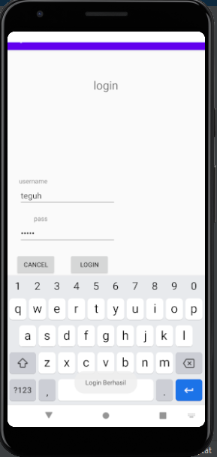

**Setelah berhasil Login akan redirect ke home database.**

**Codingan**

<RelativeLayout xmlns:android="http://schemas.android.com/apk/res/android"  
 xmlns:tools="http://schemas.android.com/tools"  
 android:layout_width="match_parent"  
 android:layout_height="match_parent"  
 android:background="@drawable/download"  
 android:paddingBottom="@dimen/activity_vertical_margin"  
 android:paddingLeft="@dimen/activity_horizontal_margin"  
 android:paddingRight="@dimen/activity_horizontal_margin"  
 android:paddingTop="@dimen/activity_vertical_margin"  
 tools:context=".MainActivity" >  
 <TextView  
 android:id="@+id/textView1"  
 android:layout_width="wrap_content"  
 android:layout_height="wrap_content"  
 android:layout_alignParentTop="true"  
 android:layout_centerHorizontal="true"  
 android:layout_marginTop="8dp"  
 android:text="Menu Utama"  
 android:textAppearance="?android:attr/textAppearanceLarge" />  
  
 <Button  
 android:id="@+id/button2"  
 android:layout_width="wrap_content"  
 android:layout_height="wrap_content"  
 android:layout_below="@+id/button1"  
 android:layout_centerHorizontal="true"  
 android:layout_marginTop="12dp"  
 android:onClick="exit"  
 android:text="Exit"  
 tools:ignore="OnClick" />  
  
 <Button  
 android:id="@+id/button1"  
 android:layout_width="wrap_content"  
 android:layout_height="wrap_content"  
 android:layout_below="@+id/textView1"  
 android:layout_centerHorizontal="true"  
 android:onClick="Create"  
 android:text="Input Data"  
 tools:ignore="OnClick" />  
</RelativeLayout>

Activity_main2

<?xml version="1.0" encoding="utf-8"?>  
<LinearLayout xmlns:android="http://schemas.android.com/apk/res/android"  
 android:layout_width="match_parent"  
 android:layout_height="match_parent"  
 android:background="@drawable/download"  
 android:orientation="vertical" >  
 <EditText  
 android:id="@+id/nama_barang"  
 android:layout_width="wrap_content"  
 android:layout_height="wrap_content"  
 android:layout_marginTop="15dp"  
 android:ems="10"  
 android:hint="nama_barang"  
 android:inputType="text" />  
 <EditText  
 android:id="@+id/merk_barang"  
 android:layout_width="wrap_content"  
 android:layout_height="wrap_content"  
 android:layout_marginTop="15dp"  
 android:ems="10"  
 android:hint="merk_barang"  
 android:inputType="text" >  
 <requestFocus />  
 </EditText>  
 <EditText  
 android:id="@+id/harga_barang"  
 android:layout_width="wrap_content"

android:layout_height="wrap_content"  
 android:layout_marginTop="15dp"  
 android:ems="10"  
 android:hint="harga_barang"  
 android:inputType="number" >  
 <requestFocus />  
 </EditText>  
 <Button  
 android:id="@+id/buttom_submit"  
 android:layout_width="wrap_content"  
 android:layout_height="wrap_content"  
 android:hint="buttom_submit"  
 android:onClick="submit"  
 android:text="submit" />  
</LinearLayout>

Barang.java

package com.example.database;  
  
import android.content.Intent;  
import android.os.Bundle;  
import android.util.Log;  
import android.view.View;  
  
import androidx.appcompat.app.AppCompatActivity;  
  
public class Barang extends AppCompatActivity {  
 private static final String *TAG* = "Activity Lifecycle" ;  
 private long id;  
 private String nama_barang;  
 private String merk_barang;  
 private String harga_barang;  
 */**  
 \** ***@return*** *the id  
 */* @Override  
 protected void onCreate(Bundle savedInstanceState) {  
 super.onCreate(savedInstanceState);  
 setContentView(R.layout.*activity_main*);  
 Log.*i*(*TAG*, "Pada event onCreate()");  
 }  
  
 public void onClickEvent(View view){  
 Intent i = new Intent(".inputdata");  
 startActivity(i);  
 }  
 public long getId() {  
 return id;  
 }  
 */**  
 \** ***@param*** *id the id to set  
 */* public void setId(long id) {  
 this.id = id;  
 }  
 */**  
 \** ***@return*** *the nama_barang  
 */* public String getNama_barang() {  
 return nama_barang;  
 }  
 */**  
 \** ***@param*** *nama_barang the nama_barang to set  
 */* public void setNama_barang(String nama_barang) {  
 this.nama_barang = nama_barang;  
 }  
 */**  
 \** ***@return*** *the merk_barang  
 */* public String getMerk_barang() {  
 return merk_barang;  
 }  
 */**  
 \** ***@param*** *merk_barang the merk_barang to set  
 */* public void setMerk_barang(String merk_barang) {  
 this.merk_barang = merk_barang;  
 }  
 */**  
 \** ***@return*** *the harga_barang  
 */* public String getHarga_barang() {  
 return harga_barang;  
 }  
 */**  
 \** ***@param*** *harga_barang the harga_barang to set  
 */* public void setHarga_barang(String harga_barang) {  
 this.harga_barang = harga_barang;  
 }  
 @Override  
 public String toString()  
 {  
 return "Barang "+ nama_barang +" "+ merk_barang + " "+harga_barang;  
 }  
  
}

DBDataSource

package com.example.database;  
  
import android.content.ContentValues;  
import android.content.Context;  
import android.database.Cursor;  
import android.database.SQLException;  
import android.database.sqlite.SQLiteDatabase;  
import android.util.Log;  
  
import java.util.ArrayList;  
  
public class DBDataSource {  
 //inisialiasi SQLite Database  
 private SQLiteDatabase database;  
  
  
 private DBHelper dbHelper;  
 private String[] allColumns = { DBHelper.*COLUMN_ID*,  
 DBHelper.*COLUMN_NAME*, DBHelper.*COLUMN_MERK*,DBHelper.*COLUMN_HARGA*};  
  
 public DBDataSource(Context context)  
 {  
 dbHelper = new DBHelper(context);  
 }  
 public void open() throws SQLException {  
 database = dbHelper.getWritableDatabase();  
 }  
  
 public void close() {  
 dbHelper.close();  
 }  
 public Barang createBarang(String nama, String merk, String harga) {  
  
 ContentValues values = new ContentValues();  
 values.put(DBHelper.*COLUMN_NAME*, nama);  
 values.put(DBHelper.*COLUMN_MERK*, merk);  
 values.put(DBHelper.*COLUMN_HARGA*, harga);  
 long insertId = database.insert(DBHelper.*TABLE_NAME*, null,  
 values);  
 Cursor cursor = database.query(DBHelper.*TABLE_NAME*,  
 allColumns, DBHelper.*COLUMN_ID* + " = " + insertId, null,  
 null, null, null);  
  
 cursor.moveToFirst();  
  
  
 Barang newBarang = cursorToBarang(cursor);  
  
 cursor.close();  
 return newBarang;  
 }  
 private Barang cursorToBarang(Cursor cursor)  
 {  
 Barang barang = new Barang();  
 Log.*v*("info", "The getLONG "+cursor.getLong(0));  
 Log.*v*("info", "The setLatLng"  
 +cursor.getString(1)+","+cursor.getString(2));  
 barang.setId(cursor.getLong(0));  
 barang.setNama_barang(cursor.getString(1));  
 barang.setMerk_barang(cursor.getString(2));  
 barang.setHarga_barang(cursor.getString(3));  
  
 return barang;  
 }  
 public ArrayList<Barang> getAllBarang() {  
 ArrayList<Barang> daftarBarang = new ArrayList<Barang>();  
  
 Cursor cursor = database.query(DBHelper.*TABLE_NAME*,  
 allColumns, null, null, null, null, null);  
 while (!cursor.isAfterLast()) {  
 Barang barang = cursorToBarang(cursor);  
 daftarBarang.add(barang);  
 cursor.moveToNext();  
  
 cursor.close();  
 return daftarBarang;  
 }  
 return daftarBarang;  
 }  
}

DBhelper.java

package com.example.database;  
  
import android.content.Context;  
import android.database.sqlite.SQLiteDatabase;  
import android.database.sqlite.SQLiteOpenHelper;  
import android.util.Log;  
  
import java.util.List;  
  
public class DBHelper extends SQLiteOpenHelper {  
 public static final String *TABLE_NAME* = "appl_inventori";  
 public static final String *COLUMN_ID* = "_id";  
 public static final String *COLUMN_NAME* = "nama_barang";  
 public static final String *COLUMN_MERK* = "merk_barang";  
 public static final String *COLUMN_HARGA* = "harga_barang";  
 private static final String *db_name* ="inventori.db";  
 private static final int *db_version*=1;  
  
 private static final String *db_create* = "create table "  
 + *TABLE_NAME* + "("  
 + *COLUMN_ID* +" integer primary key autoincrement, "  
 + *COLUMN_NAME*+ " varchar(30) not null, "  
 + *COLUMN_MERK*+ " varchar(30) not null, "  
 + *COLUMN_HARGA*+ " varchar(30) not null);";  
  
 public DBHelper(Context context) {  
 super(context, *db_name*, null, *db_version*);  
 }  
  
 @Override  
 public void onCreate(SQLiteDatabase db) {  
 db.execSQL(*db_create*);  
 }  
  
 @Override  
 public void onUpgrade(SQLiteDatabase db, int oldVersion, int  
 newVersion) {  
 Log.*w*(DBHelper.class.getName(),"Upgrading database from version"  
 + oldVersion + "to "  
 + newVersion + ", which will destroy all old data");  
 db.execSQL("DROP TABLE IF EXISTS " + *TABLE_NAME*);  
 onCreate(db);  
  
 }  
 public void add(com.example.database.Barang barang) {  
 // *TODO Auto-generated method stub* }  
 public List<com.example.database.Barang> getAllBarang() {  
 // *TODO Auto-generated method stub* return null;  
 }  
 public void addBarang(com.example.database.Barang barang) {  
 // *TODO Auto-generated method stub* }  
}

mainActivity.java

package com.example.database;  
  
import android.content.Intent;  
import android.os.Bundle;  
import android.view.Menu;  
import android.view.View;  
import android.widget.Button;  
  
import androidx.appcompat.app.AppCompatActivity;  
  
  
public class MainActivity extends AppCompatActivity {  
  
 @Override  
 protected void onCreate(Bundle savedInstanceState) {  
 super.onCreate(savedInstanceState);  
 setContentView(R.layout.*activity_main*);  
 Button Create = (Button)findViewById(R.id.*button1*);  
 Create.setOnClickListener(new View.OnClickListener() {  
  
 //jika di klik maka akan ada aksi  
 public void onClick(View v) {  
 Intent i=new Intent(getApplicationContext(),MainActivity2.class);  
  
 startActivity(i);  
 }  
 });  
 }  
 @Override  
 public boolean onCreateOptionsMenu(Menu menu) {  
 // Inflate the menu; this adds items to the action bar if it is  
  
 getMenuInflater().inflate(R.menu.*main*, menu);  
 return true;  
 }  
  
  
}

mainActivity2.java

package com.example.database;  
  
import android.app.Activity;  
import android.content.Intent;  
import android.os.Bundle;  
import android.view.View;  
import android.view.View.OnClickListener;  
import android.widget.Button;  
  
//menggunakan implements di classnya  
public class MainActivity2 extends Activity implements OnClickListener{  
 protected void onCreate(Bundle savedInstanceState) {  
 super.onCreate(savedInstanceState);  
 setContentView(R.layout.*activity_main2*);  
  
 Button move = (Button)findViewById(R.id.*buttom_submit*);  
 move.setOnClickListener(this);  
 }  
 @Override  
 public void onClick(View v) {  
 // *TODO Auto-generated method stub* if(v.getId()==R.id.*buttom_submit*) {  
 Intent i=new Intent(this,MainActivity2.class);  
 startActivity(i);  
 finish();//menghapus history class ini  
 }  
 }  
}

androidmanivest.xml

<?xml version="1.0" encoding="utf-8"?>  
<manifest xmlns:android="http://schemas.android.com/apk/res/android"  
 xmlns:tools="http://schemas.android.com/tools"  
 package="com.example.database">  
 android:versionCode="1"  
 android:versionName="1.0"  
  
 <uses-sdk  
 android:minSdkVersion="8"  
 android:targetSdkVersion="17" />  
  
 <application  
 android:allowBackup="true"  
 android:icon="@mipmap/ic_launcher"  
 android:label="@string/app_name"  
 android:roundIcon="@mipmap/ic_launcher_round"  
 android:supportsRtl="true"  
 android:theme="@style/AppTheme">  
 <activity android:name=".MainActivity2"></activity>  
 <activity android:name=".MainActivity">  
 <intent-filter>  
 <action android:name="android.intent.action.MAIN" />  
  
 <category android:name="android.intent.category.LAUNCHER" />  
 </intent-filter>  
 </activity>  
 <activity  
 android:name="com.example.database.Barang"  
 android:label="title_activity_main"  
 tools:ignore="Instantiatable">  
  
 </activity>  
 </application>  
  
</manifest>

Tampilan Database.

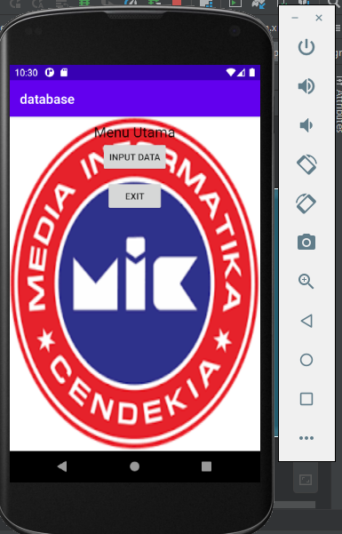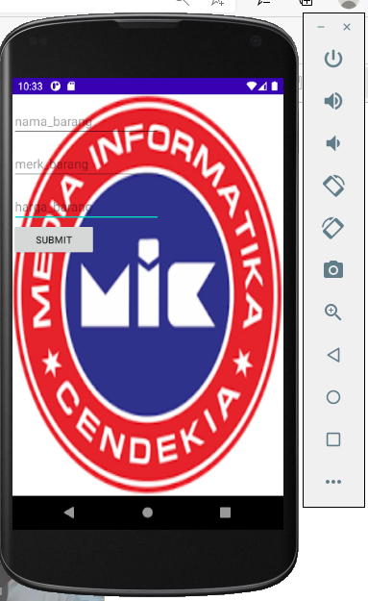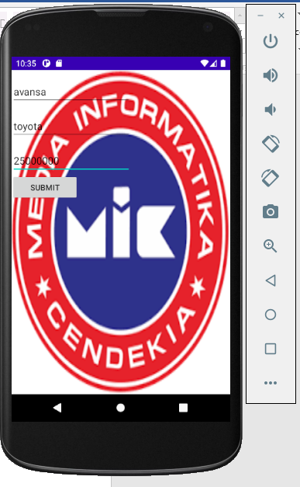

**Pilihan jawaban pakai stabilo kuning**

**Jawaban Ujian Pilihan Ganda**

1. Mobile Computing merupakan kemampuan teknologi untuk menghadapi : *
2. Pergerakan Hewan
3. Pergerakan Tumbuhan
4. Pergerakan Manusia
5. Pergerakan Angin
6. Atribut sering dipakai dalam pemrograman mobile, kecuali : *
7. Fill_Content
8. Wrap_Content
9. Fill_Parent
10. Match_Parent
11. Jika ada script ini : tools:context=".MainActivity" mengarah ke: *
12. MainActivity.java
13. ActivityMain.java
14. MainActivity.xml
15. ActivityMain.xml
16. Agar lebar atau tinggi mengikuti object dalam komponen tersebut menggunakan : *
17. Fill_Content
18. Wrap_Content
19. Fill_Parent
20. Match_Parent
21. Dibawah ini yang tidak menjelaskan tentang smartphone atau mobile device? *
22. Sebuah perangkat genggam
23. Berjalan pada native apps
24. Membutuhkan virtual machine untuk menjalankannya
25. Terintegrasi dengan sebuah telepon selular
26. Tujuan utama Java adalah : *
27. Satu bahasa, Satu Platform
28. Tulis sekali, jalankan dimanapun
29. Java, Java dimanapun!
30. Tidak ada satupun
31. Lengkapi coding ini : android:src=" ................/logostmikmic" *
32. @string
33. @+id
34. @drawable
35. @color
36. Dibawah ini dipastikan ketikan codingnya akan mengalami error : *
    1. privateString namabarang;
    2. private String merkbarang;
    3. private String harga barang;
    4. private String jumlahbarang;
37. private static final ............ db_create= "create table "+ TABLE_NAME+ "("+ COLUMN_ID+" integer primary key autoincrement, "+ COLUMN_NAME+ " varchar(30) not null, "+ COLUMN_MERK+ " varchar(30) not null, "+ COLUMN_HARGA+ " varchar(30) not null);"; *
38. integer
39. string
40. char
41. byte
42. if(v.............()==R.id.btnmain) {Intent i=new Intent(this,target1.class);startActivity(i);finish(); *
43. intentId
44. getId
45. classId
46. startId